Medication Deprescribing Methodology

for Planned Cessation

of Non-Essential Medications

Challenge
Many patients take too many medications, many of which were prescribed long ago, without attempts to decrease or stop them, or exploring benefits versus harm for continuing.
In addition, patients often do not adhere to medication schedules due to side effects, compromised abilities to manage medication schedules, confusion, or cost.
A holistic approach is critical to efficiently and continually:
- make medications work for patients and not against them ● identify PIM ● intervene as needed.

Innovation
Deprescribe (verb): Intentionally stop a medication or reduce its dose to improve outcomes and reduce the risk of adverse, undesirable side effects.

VIONE is a methodology to reduce polypharmacy by identifying and discontinuing unnecessary, ineffective, and inappropriate medications that do more to harm or burden patients than to help them.
VIONE is part of the VA’s Electronic Health Records (EHR). It can be used across any patient care setting, including hospitals, homes, rural areas, outpatient facilities, and virtual health modalities such as telehealth.
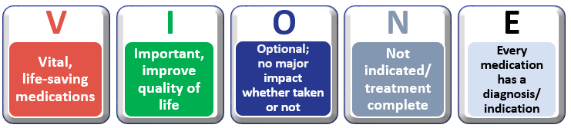
Medical providers and pharmacists can deprescribe Potentially Inappropriate Medications (PIM), while engaging patients, surrogate decision makers, and other health care professionals.

VIONE is not a substitute for careful clinical consideration. It prompts attention to non-pharmaceutical, whole health approaches in simple and practical ways with proactive deprescribing practices.

Medication Reconciliation vs VIONE

Medication Reconciliation  A list of prescribed medications, herbal products, and OTC medications taken by the Veteran.  GOAL: Confirm and document an accurate and current medication list. | VIONE  A simple electronic tool that focuses on  whether a Veteran should or should not be  taking a medication on their current medication list.  GOAL: Create a medication regimen that is helpful, not harmful.

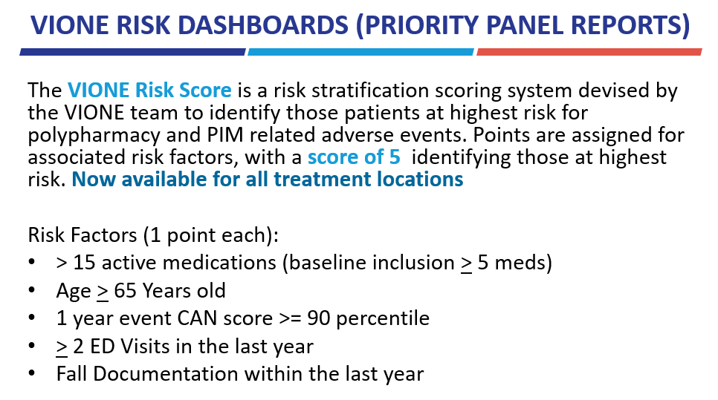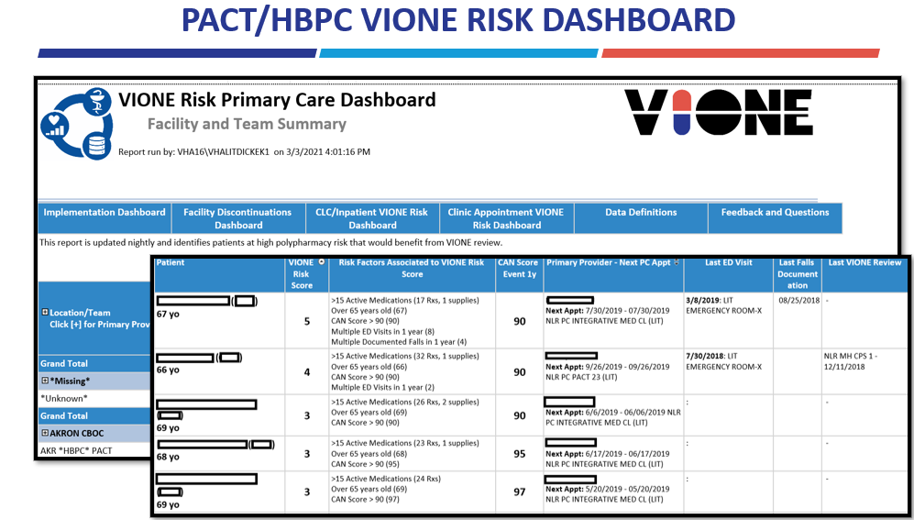
VIONE DASHBOARDS:PACT/HBPC | CLC/Inpatient : Upcoming Appt

How VIONE works in Electronic Health Records:
- Review Medications – consider VIONE deprescribing filters for each medication
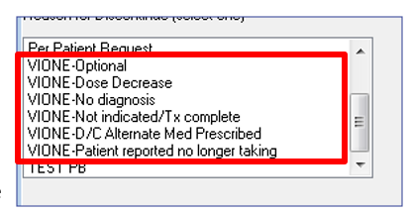
- In CPRS, click on:
  - Medication
  - Actions
  - Discontinue – drop down menu
- Choose VIONE reasons to discontinue
- Discuss with patient and/or surrogate decision-maker
- Make deprescribing decisions based on clinical review in the best interests of the patient
- Document in progress note – add collaborating pharmacist and/or providers as cosigners
- Data is automatically captured every day when VIONE options are selected and/or VIONE note template is utilized for deprescribing medications.
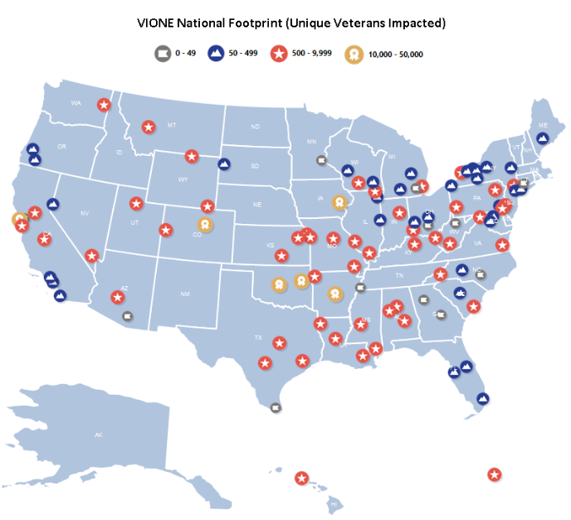

VIONE Impact:
April 1, 2016 - March 31, 2021:
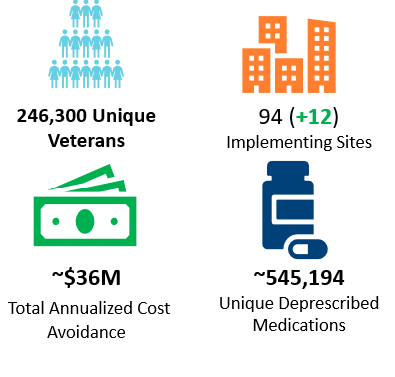
VIONE Dashboard Link: Program Implementation Dashboard
At Your Facility:
Resources for implementation may be found at
https://dvagov.sharepoint.com/sites/vhaacademicdetailing/ClassicMigration/sitepages/vione.aspx
or VAVIONE@VA.GOV March, 2021 MEDVAMC, Houston, Texas

