VA Geriatric ED Quality Improvement Process Template: Level 1 & 2 Breakout Session

You will use this during your breakout session to lay out your foundation.

1. Site:
2. Level:
3. MD Champion:
4. RN Champion:
5. Interdisciplinary Team: ICT: ___________________

SW: ___________________

Pharmacist:_____________

PT/OT:_________________

Other:_________________

1. Geriatric Age:
2. Screen(s) to be implemented:
3. Screener workflow:
4. Location of screen in workflow: [triage, RN assessment note, SW note, ICT note]

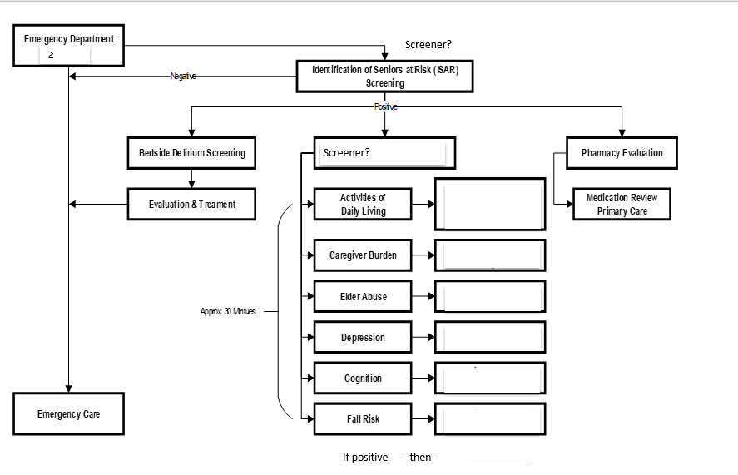

1. Follow up process for positive screen: [refer to [Playbooks link](https://dvagov.sharepoint.com/:f:/r/sites/VAEMGeriatrics/Shared%20Documents/GEDA%20Onboarding%20Packages/Playbooks_Order%20Sets?csf=1&web=1&e=V8SdqV) and algorithm below]
   1. List the geriatric resources accessible to your ED
   2. List the geriatric resources available in your hospital for follow up
   3. Consider creating a quick access Geriatric ED Consult Menu (see last page of this document for example).
2. If initiative does not involve a screen:
   1. When/how is process triggered?
   2. Who enacts the initiative?
3. Is there a Standard Operating Procedures manual / Guideline?
   1. Does one need to be written?
   2. Who will write it?
   3. Who will need to review and sign?
4. Staff Education Plan:
   1. Provider:
   2. Nurse:
   3. SW:
   4. ICT:
5. Equipment/resources:
6. Plan for monitoring the process and compliance:
7. Anticipated challenge(s):
   1. Plan(s) to address challenge:\
8. Go Live date:

**Example Algorithm of Workflow**



**Example: Quick Access Geriatric ED Consult Menu**

