Plan-Do-Study-Act Record |  | DATE:
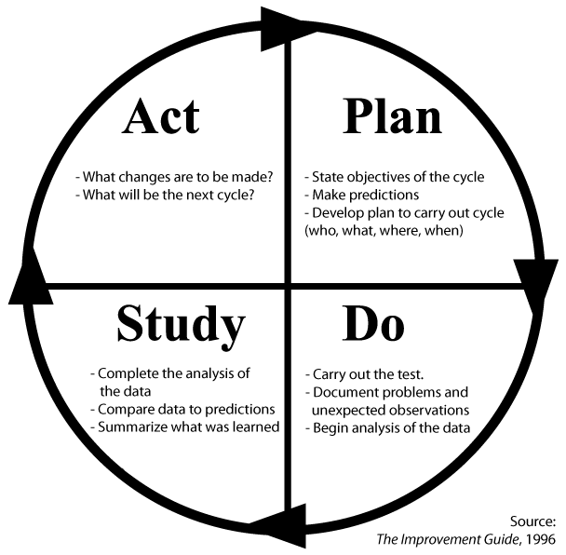 | Which topic(s) from the buffet are you testing?

Describe the change or test using SMART goal format?

(SMART goals are: Specific, Measureable, Achievable, Relevant, Timebound)
What are your trying to accomplish? How much? By when?

What information (data) will we collect to evaluate the change or test?

What predictions can we make about the change or test?

